**JMeter Functions And Variables**

Function – methods used to populate fields in any other elements of a test plan

Syntax:

${__functionName}

${__functionName(var1,var2,…)}

Variables – Containers that can store values, which can be referred in any element within a thread.

Syntax:

${varName}

Steps:

* Create Thread Group
* Add Java Request

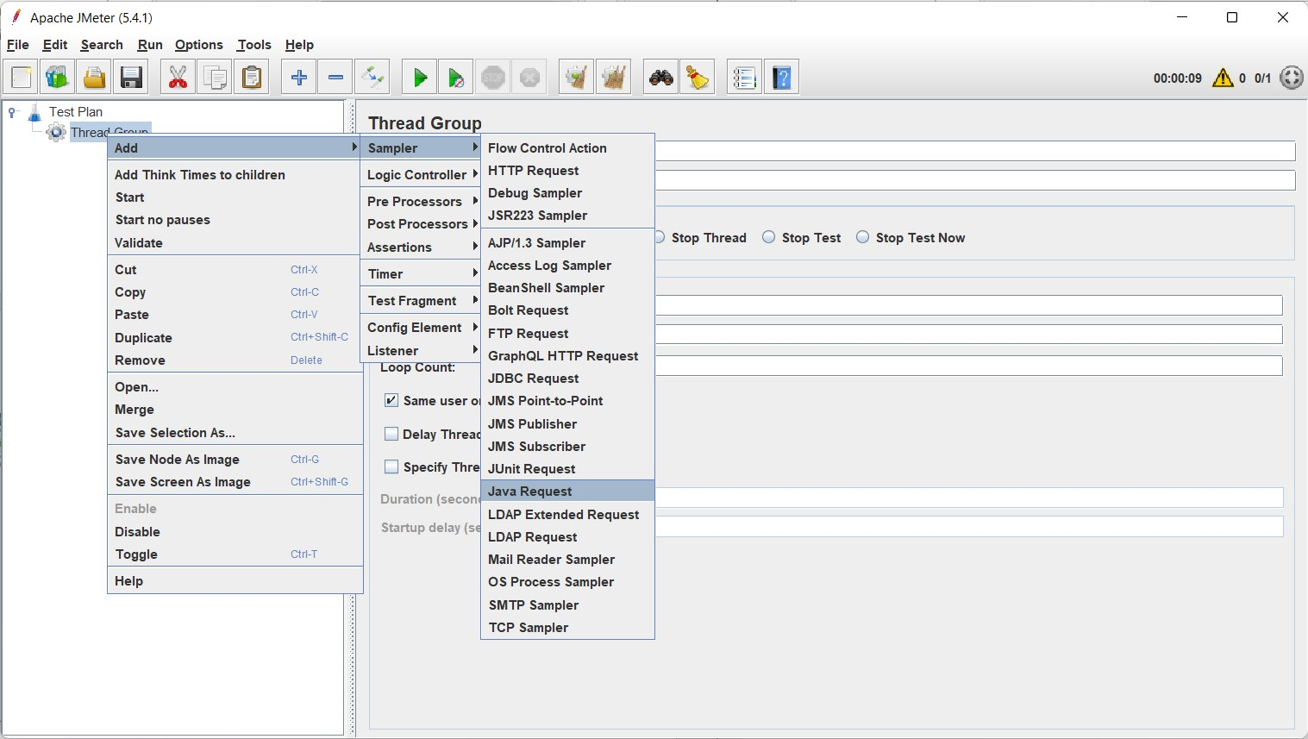

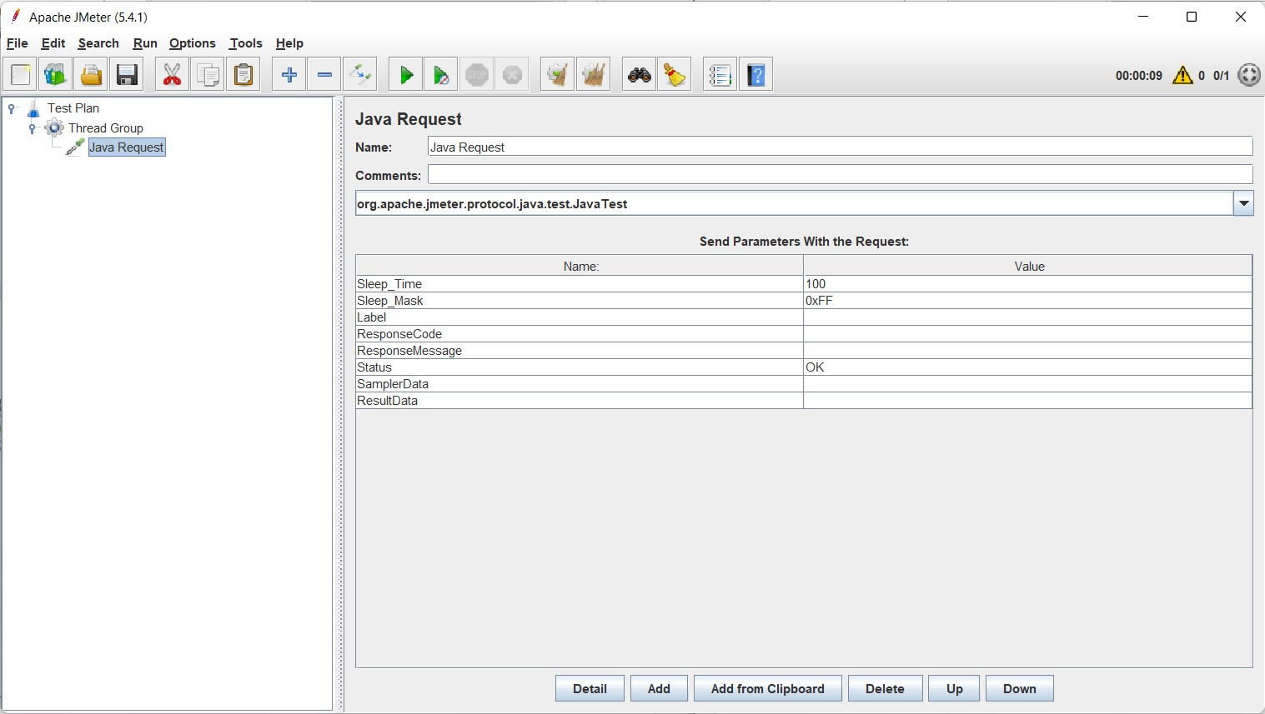

LOG FUNCTION

* Goto Tools and select Funtion Helper Dialogue
* Generate log function using function helper dialogue

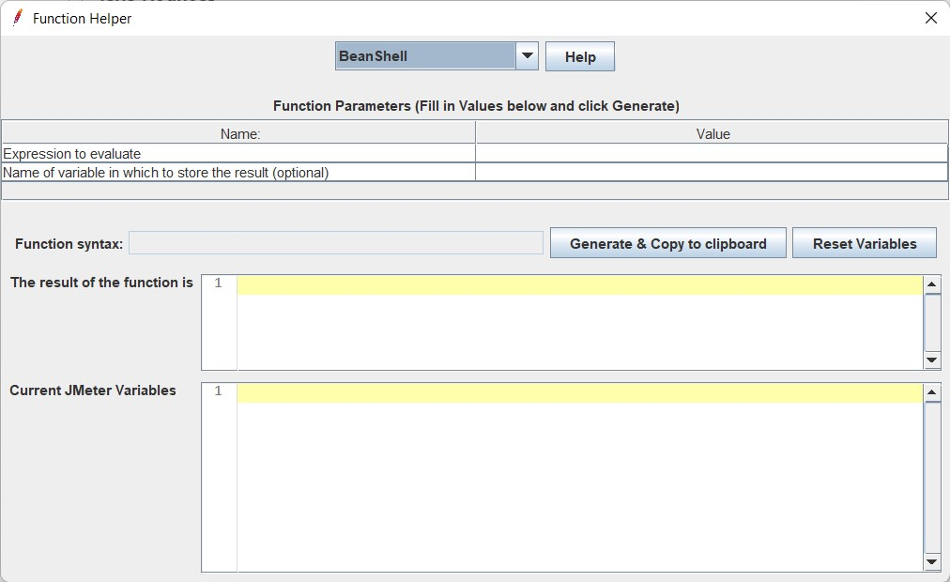

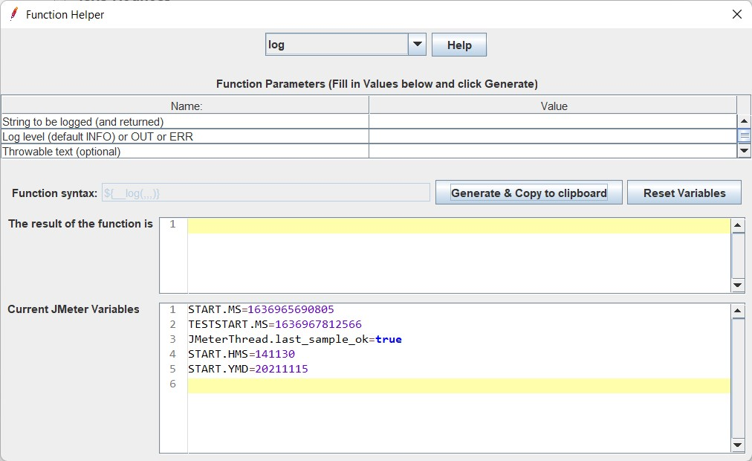

Give string name as “Hello World” and click generate.

Now paste it on the name field of request

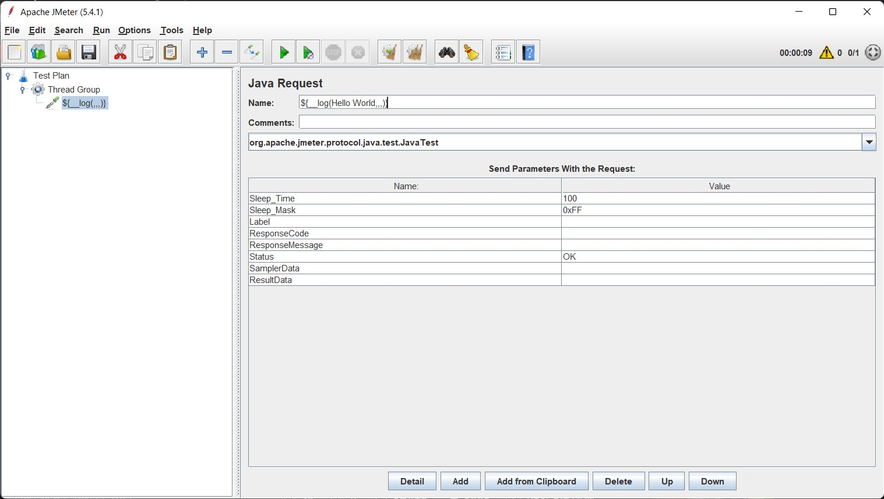

Now add a listener to view the result and click run

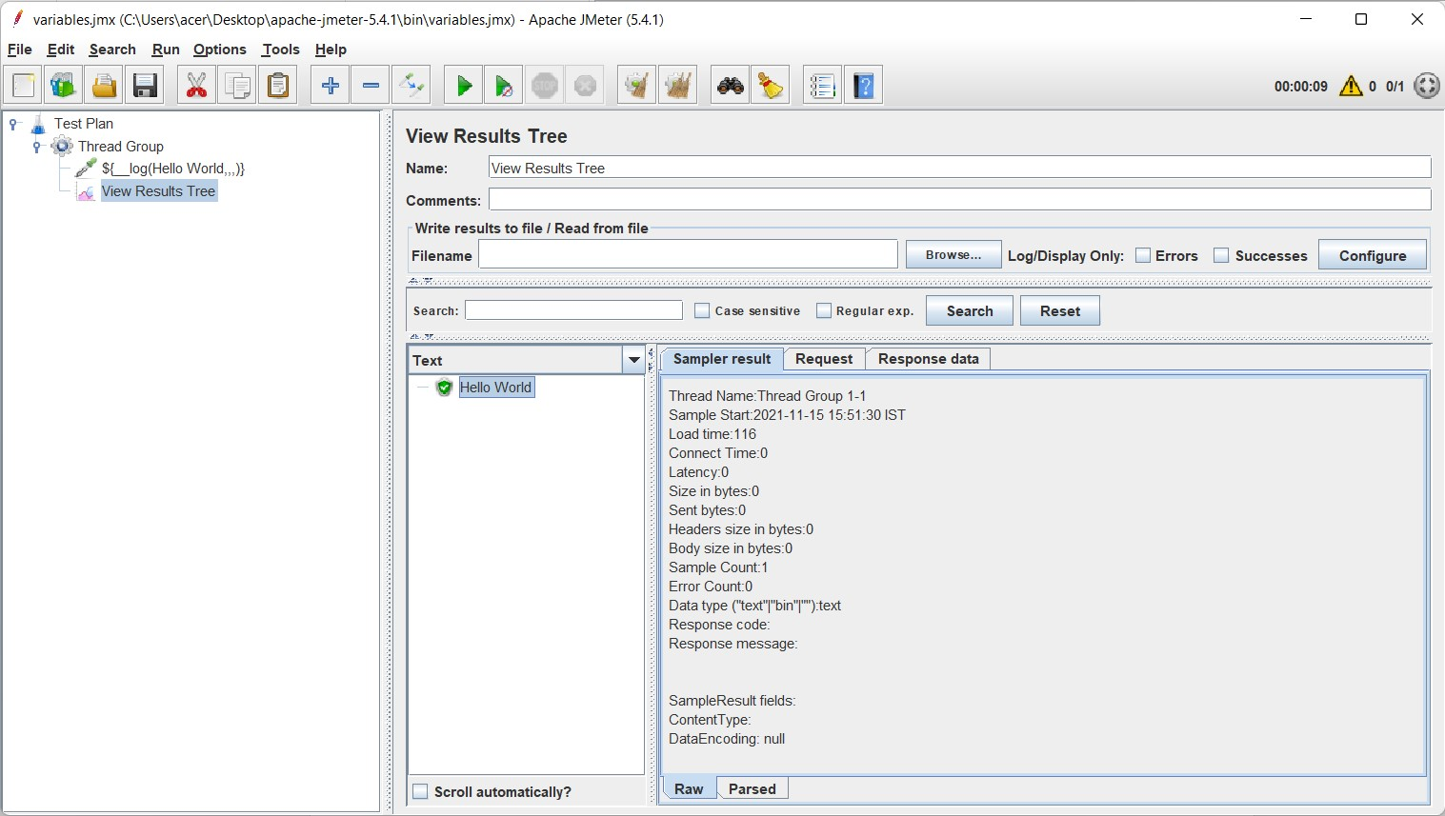

TIME FUNCTION

Add another function time using the same method. Click generate.

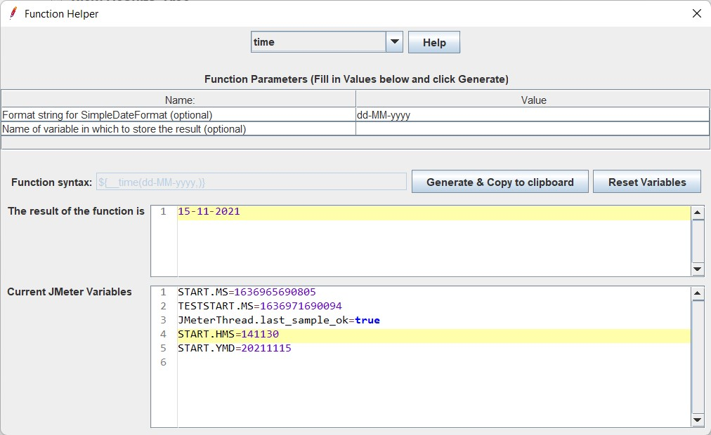

Add another sampler -> java request and paste in the name field. Now see the result

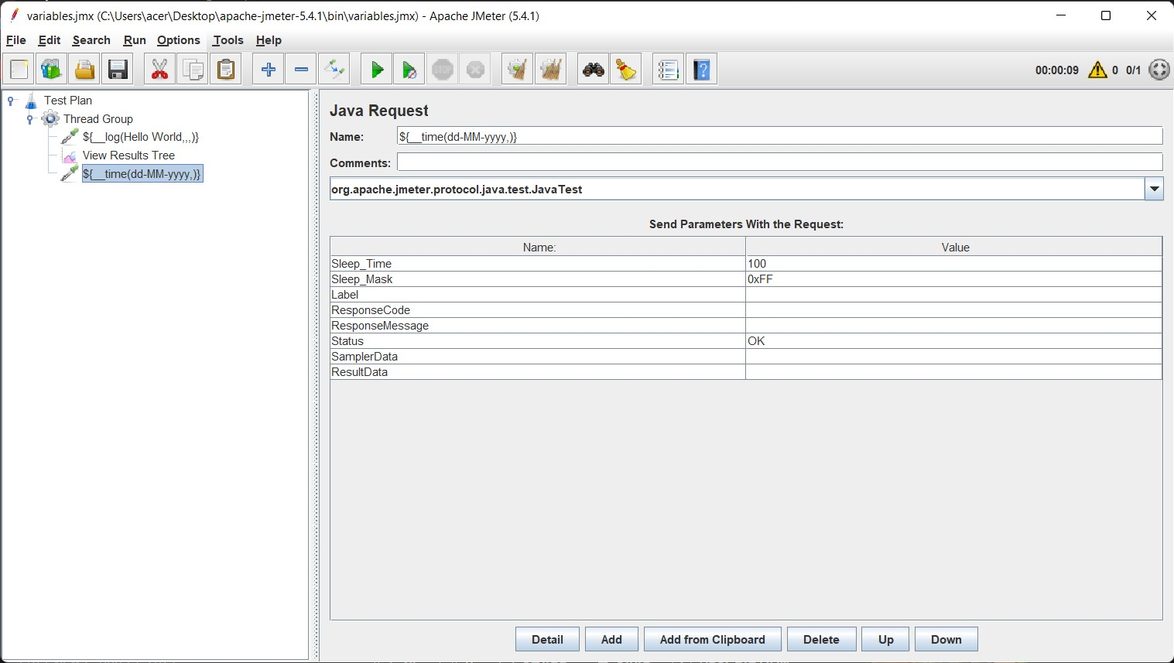

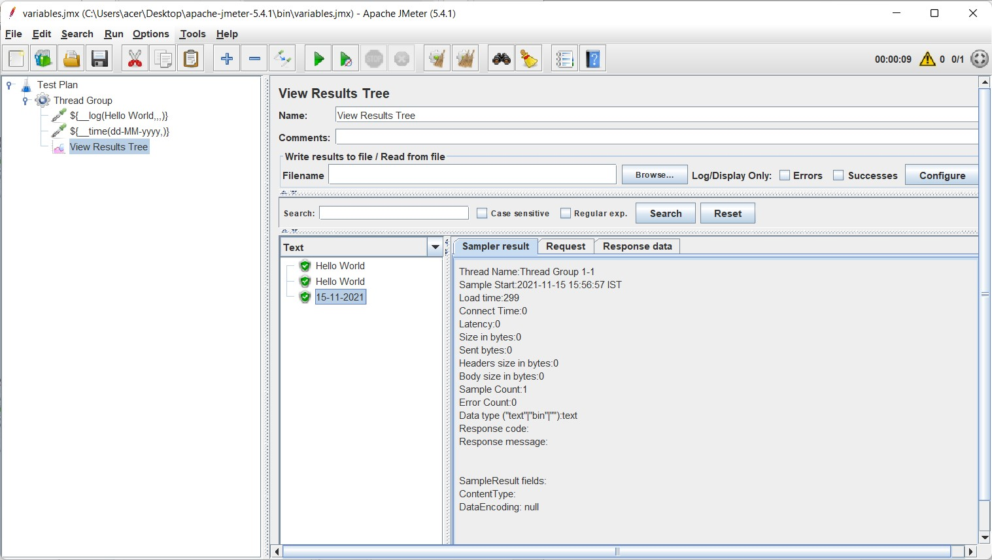

THREAD NUM FUNCTION – number of current threads.

Follow the same procedure as above.

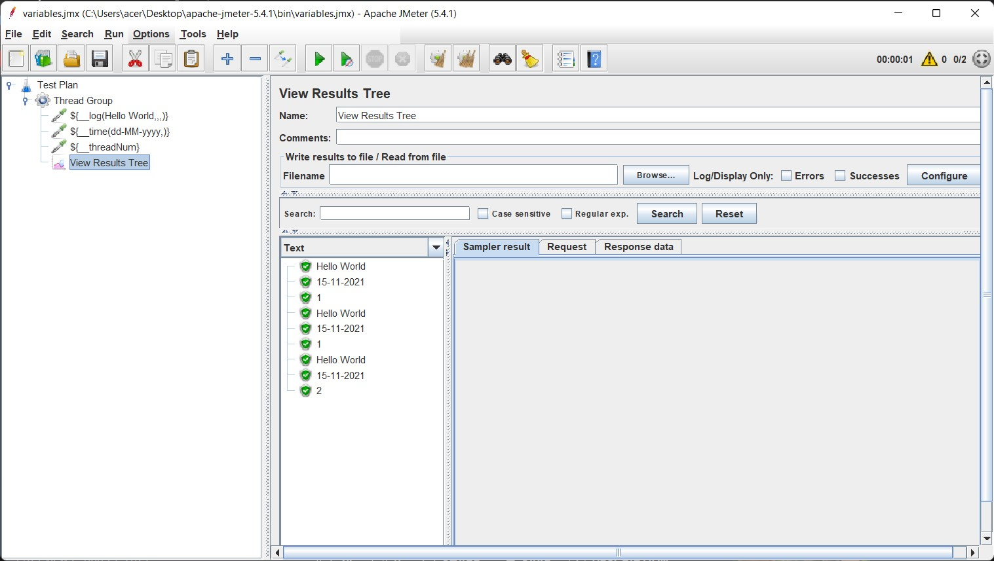

IntSum FUNCTION

Put 2 and 3 as intigers to add in function helper dialogue

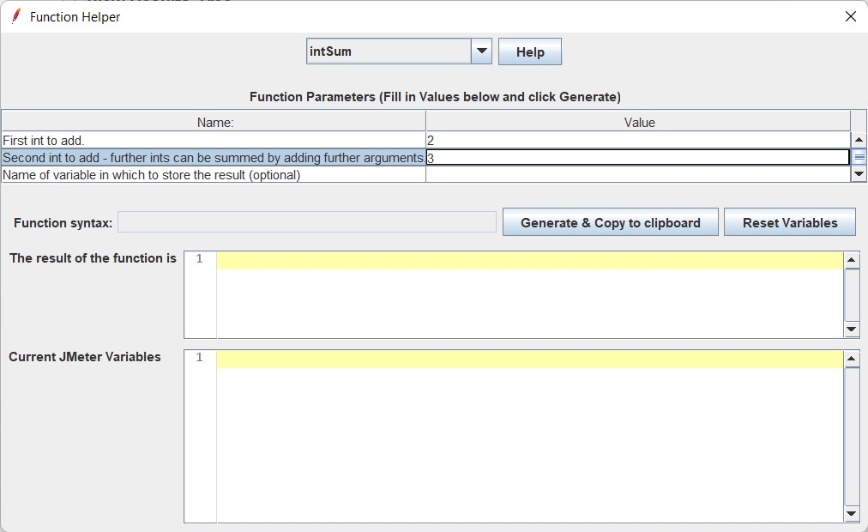

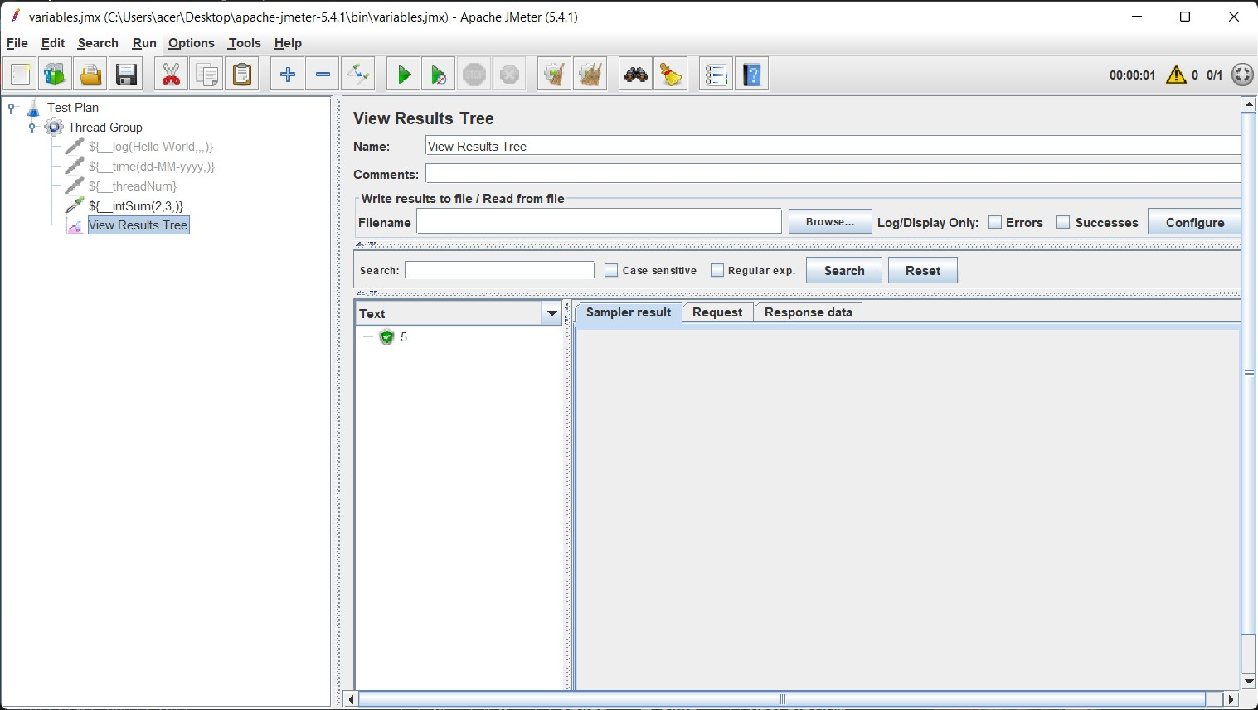

The sum of 2 and 3 is shown here in the test output.

Now we can store the result of the above operation in a variable “result” by renaming the request.

This Variable can be used anywhere in the thread.

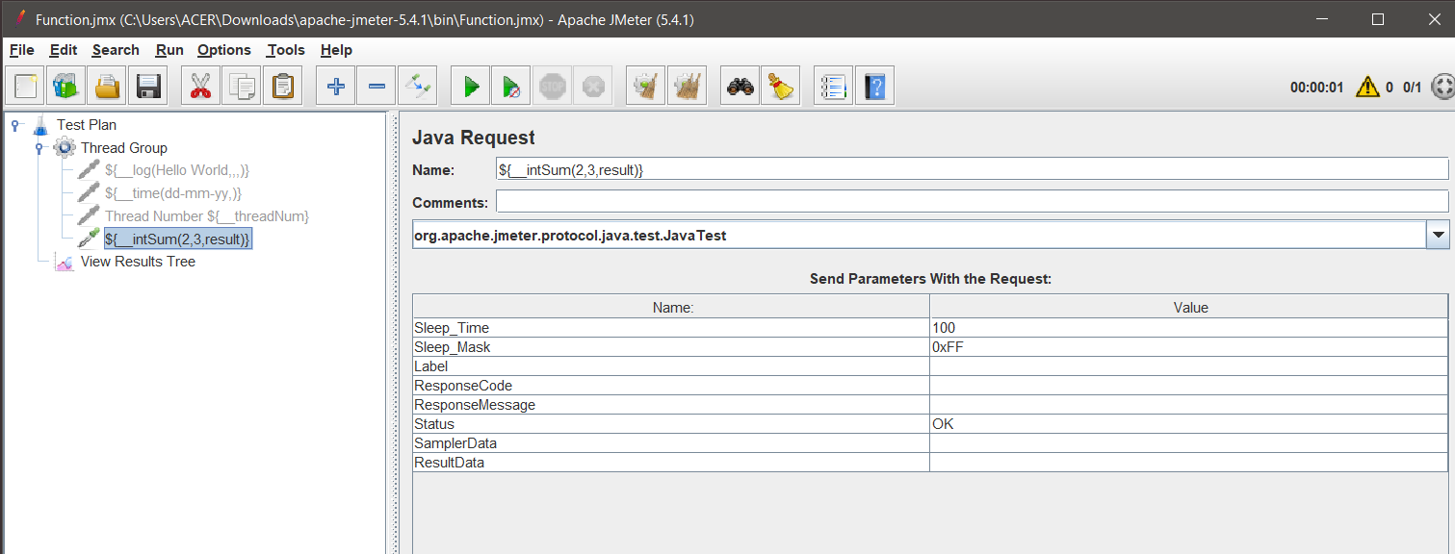

Using the variable “result” as operand in intsum function.

